TTL Flash Principles Applied to Olympus E-xx

The E-xx and the FL-40 manuals don’t give any insight to the way the camera works with the flash and the instructions are very scant. After much frustration I decided to perform a series of tests and try to understand what’s happening.

TTL Flash Principles

With TTL flash the camera measures the intensity of flash light (illumination) falling on the CCD and integrates it over elapsed time until a predefined threshold light energy is reached. At that time the camera quenches the flash output and exposure is terminated. For simplicity, we assume a rectangular pulse so exposure (light energy) is proportional to the product of light intensity and time.

E = I₁ x T_{E}

Where: E - Exposure threshold set by the camera (depends on ISO rating)
I - CCD illumination
T_{E} - Flash quenching time

The maximum exposure available is E_{max} = I₁ x T_{Max}. T_{Max} is determined by the flash and is a fixed value. The illumination I depends among other things on the flash to subject distance and the f number (aperture).

If the illumination of the CCD decreases, the required T_{E} increases, and if it exceeds T_{Max} as shown in the next diagram, we will have under-exposure, because after T_{Max} there is no more flash light.

Thus, there is a ‘TTL Range’, which may be expressed as distance or f numbers, or a combination of the two, over which TTL is effective. Beyond this range we can no longer rely on TTL.

TTL Flash with E-xx

Up until now it’s all ‘classic TTL’, not specific to the E-xx. However, E-xx has the option for ‘Flash bias’, set through the menu, from –2 to +2. What does the bias do, does it increase or decrease the flash intensity? Does it increase T_{Max}? The manual doesn’t say anything. The conclusion I reached, and I’ll try to prove it through the sample shots I’ll show, is that the bias does not affect the flash in any way, it does not increase/decrease its power, neither in intensity nor in maximum pulse duration. What it does is change the ‘Required light energy’ threshold, thus if you set a negative bias, the threshold is lower, T_{E} will be shorter, and you’ll get less exposure. If you set a positive bias, the threshold will be higher, T_{E} will be longer, and you’ll get more exposure.

T_{E} is the zero bias time. If we select a negative bias we get a shorter time T_{E-} and for a positive bias a longer time T_{E+} until the flash is quenched, and correspondingly, lower or higher exposure.

The next sample shots show the results of changing the bias from –2 to +2:

Mode: M, f:4, S = 1/250, F = 18mm, ESP, WB = Auto, ISO = 80
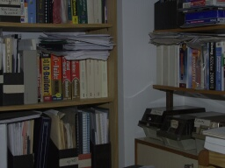 | 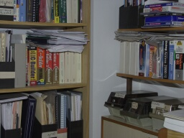 | 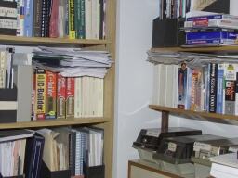 | 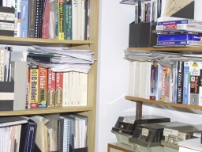 | 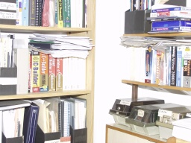
Flash bias -2 | Flash bias -1 | Flash bias 0 | Flash bias +1 | Flash bias +2
AUTO CHECK + | AUTO CHECK + | AUTO CHECK + | AUTO CHECK + | AUTO CHECK +

Samples were taken in M mode with FL-40 in direct (not bounced) mode, f:4, 1/250sec. Distance to subject 2m, room size: 3 X 3m, ceiling height: 3m. Walls and ceiling white-washed.

We see how exposure changes relative to the zero-bias position: negative bias reduces exposure while positive bias increases it.
All is well as long as we are within the ‘TTL Range’, i.e. T_{E+} is shorter than T_{Max}. But if we increase distance or f number (or both) we may get out of this range and the positive bias will not help to increase exposure, as can be seen in the next diagram:

In this example illumination is barely sufficient for zero-bias (T_{E} = T_{Max}). If we set a positive bias
(T_{E+} > T_{Max}) we will not get additional exposure because there is no flash light after time T_{Max}.

Mode: M, f: 8, S = 1/250, F = 18mm, ESP, WB = Auto, ISO = 80
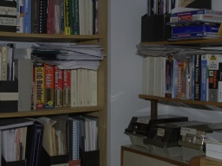 | 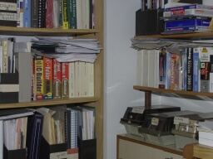 | 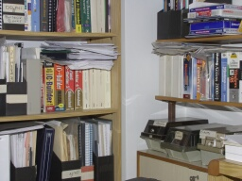 | 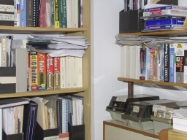 | 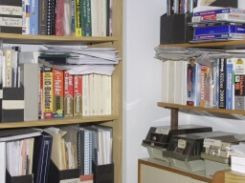
Flash bias -2 | Flash bias -1 | Flash bias 0 | Flash bias +1 | Flash bias +2
AUTO CHECK + | AUTO CHECK + | AUTO CHECK + | AUTO CHECK - | AUTO CHECK -

Unlike the previous set of samples, we see here that exposure did not increase with positive bias, and that’s because we are at the edge of the TTL Range. Conditions here are the same as before, except that f number is now 8 (instead of 4).

The AUTO CHECK lamp on the flash indicates whether the TTL cycle completed or not. If the lamp does not blink after the shot it means there was not sufficient flash power to satisfy TTL requirement. In the example above, the lamp did not blink for bias +1 and +2. Unfortunately, the AUTO CHECK lamp is not linked to the flash icon in the view finder (which blinks during flash charge time), so you must take away your eye from the finder and look at the flash.

With internal flash (instead of the FL-40), results are similar:

Mode: M, f:4, S = 1/250, F = 18mm, ESP, WB = Auto, ISO = 80
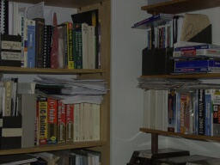 |  |  |  | 
Flash bias -2 | Flash bias -1 | Flash bias 0 | Flash bias +1 | Flash bias +2
AUTO CHECK + | AUTO CHECK + | AUTO CHECK + | AUTO CHECK + | AUTO CHECK +

Samples were taken in M mode with internal flash, f:4, 1/250sec. Distance to subject 2m,
room size: 3 X 3m, ceiling height: 3m. Walls and ceiling white-washed.

Here we are inside the TTL Range, not at the edge. The similar behavior of the internal and external flashes indicates that the internal flash is also TTL (I couldn’t find it in the manual).

One conclusion of the discussion so far is that setting a positive flash bias will not increase the flash power and will not permit a larger TTL range (distance or f number).

Bounced Flash

All test so far were with direct flash. With bounced flash there are more factors involved and it’s difficult to conduct a controlled test. The important parameter to determine is the TTL Range for various conditions. If we want to take advantage of the TTL feature we must strive to work within this range.

I don’t think there is any other method but trial and error for determining that range. The tests in the previous section should provide a clue on how to determine the TTL Range. The range will be different for every ‘environment’ – combination of subject distance, room size, ceiling height, walls colure, bounce angle, etc.

Start with flash bias set to 0 and maximum f number and take the first shot. The AUTO CHECK lamp will probably not blink. Reduce f number (open up aperture) until the AUTO CHECK lamp starts to blink after a shot. That should give you the range edge (f:8 in the sample shots above). At this point setting positive bias values will not increase exposure (AUTO CHECK lamp will not blink), setting negative bias values will decrease exposure (AUTO CHECK lamp will blink).
I carried out the test for a few typical cases:

FL-40 with LUMIQUEST PROMAX POCKET BOUNCER attached, same environment as tests above:
I started at f:5.6 and went down to f:2.8 for the AUTO CHECK lamp to begin blinking. At this point I took 5 shots with flash bias –2, -1, 0, +1, +2

Mode: M, f:2.8, S = 1/250, F = 18mm, ESP, WB = Auto, ISO = 80
 | 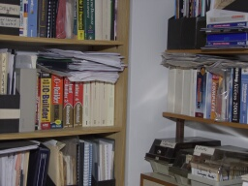 |  | 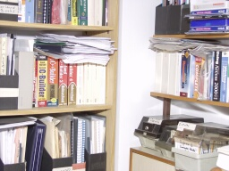 | 
Flash bias -2 | Flash bias -1 | Flash bias 0 | Flash bias +1 | Flash bias +2
AUTO CHECK + | AUTO CHECK + | AUTO CHECK + | AUTO CHECK - | AUTO CHECK -

The TTL Range edge for this environment is f:2.8. The exposure I get is the maximum, I cannot increase exposure by setting flash bias to +1 or +2.

FL-40 bounced from ceiling (60⁰), same environment as tests above:
I started at f:5.6 and went down to f:4 for the AUTO CHECK lamp to begin blinking. At this point I took 5 shots with flash bias –2, -1, 0, +1, +2

Mode: M, f:4, S = 1/250, F = 18mm, ESP, WB = Auto, ISO = 80
 |  |  |  | 
Flash bias -2 | Flash bias -1 | Flash bias 0 | Flash bias +1 | Flash bias +2
AUTO CHECK + | AUTO CHECK + | AUTO CHECK + | AUTO CHECK - | AUTO CHECK -

The TTL Range edge for this environment is f:4. The exposure I get is the maximum, I cannot increase exposure by setting flash bias to +1 or +2.

In this particular case the room was small. In a larger room you’ll probably find you must open up to maximum aperture, and even so you may be out of the TTL Range. The only way out in this case will be to increase ISO rating.

